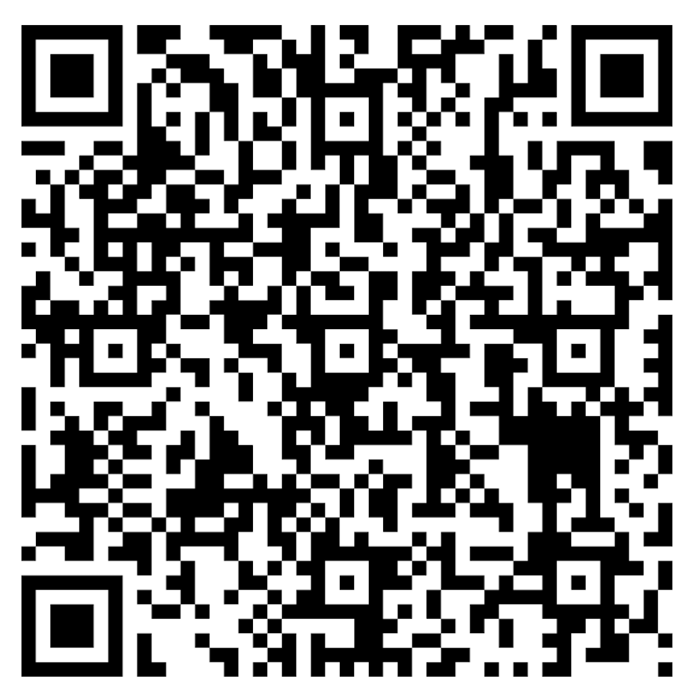
Scan this
for
Online Form

Club Application 2023-2024
Submit the online form using the QR code and return this form to the office
Club Name: ________________________________________________________________________________
Teacher Sponsor: _________________________________________________Teacher Initial: ______________

Club Description, Purpose and Mission Statement:
______________________________________________________________________________________________________________________________________________________________________________________________________________________________________________________________________________________________________________________________________________________________________________________________________________________

Club’s Executive Members:
Contact Name | Email | Phone | Executive Position | Signing Officers Signature

Proposed Events/Activities:

Regular meeting date/time: ____________________________________________________________________
Location/Room: _____________________________________________________________________________
Do you need a cash online account set up? YES NO
Have you submitted the online form? YES NO (You must submit both online and paper form)
Note: It is important to have at least two people responsible for the financials of your club.
Executives with signing authority must sign on the lines above.

For Office Use Only
Date Approved/Not Approved: __________________________________________
Account # Assigned if cash on-line requested: ______________________
Principal Signature: _____________________________________

